About Christian Clearing House……..

Christian Clearing House (CCH) is a non-profit organization serving residents of Hancock County.

In 1994, 13 local churches began a cooperative community effort to address the common concern among Christians that individuals “in need” be helped through emergency assistance.

Today, CCH is funded by 46 participating congregations, individuals, businesses, grants and fundraising events.

The organization is primarily a volunteer agency. CCH works closely with other service organizations in the area to ensure that clients receive the best help available.

All proceeds raised are for programs at Christian Clearing House.

Win a $5000 Saving Bond
Hole in One Contest

Courtesy of:
Hitchings Insurance
Agency

Win Sporting
Event Tickets
(Raffle)

Mail Registrations to:
Christian Clearing House
1800 N. Blanchard St.
Suite 107
Findlay, Ohio 45840
419-422-2222
www.hcchsupport.org

email:tstahl@hcchfindlay.org

Company Name
Company Address
City, State ZIP
Phone: 999-999-9999
Fax: 999-999-9999

Christian
Clearing
House

11th Annual
Golf Scramble

September 12, 2014
(Friday)

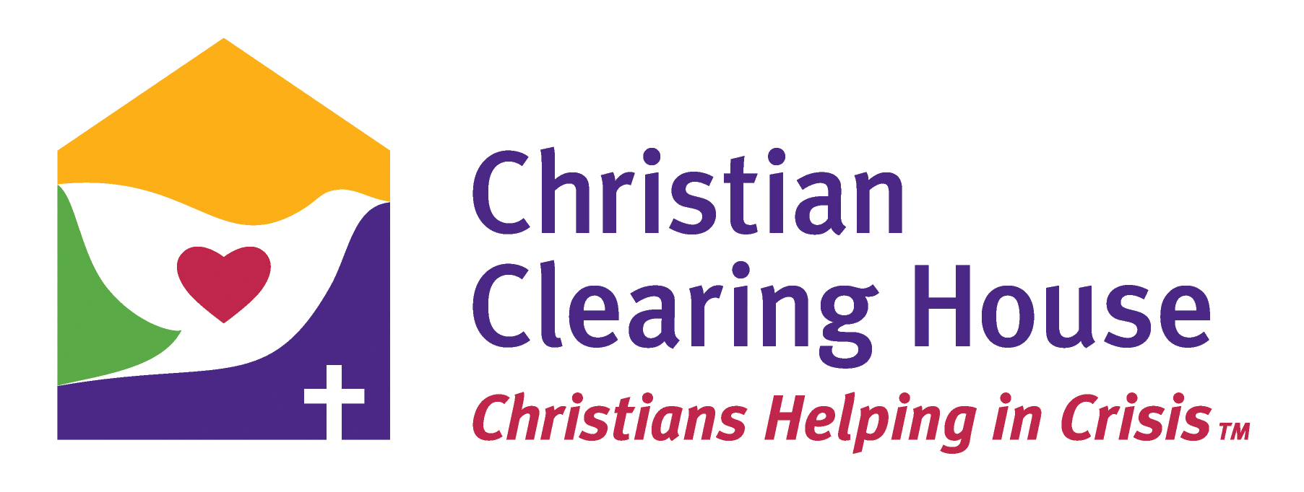

Sycamore Springs
Golf Club

“Christians Helping
In Crisis”

Company Name
Company Address
City, State ZIP
Phone: 999-999-9999
Fax: 999-999-9999

Christian Clearing House (CCH) and Sycamore Springs Golf Club invite you to help us take a swing in the fight against hunger, poverty and financial needs for Hancock County residents!

Our Mission:
To provide non-sustaining, emergency assistance to
residents and/or transients of Hancock County who have financial, physical, emotional, and/or spiritual needs and to collaborate with churches, agencies, and individuals to promote effective use of community resources.

Our Vision:
To represent Christ to the community through helping people become self-sustaining.

How CCH Helps:
In 2013, CCH helped clients with over $250,000 in direct aid programs with utilities, food rent and many other needs.
*************************************
Enjoy golfing on a beautiful course while at the same time supporting the mission of CCH!

Thank-you!

What:
Four-player Best Ball Scramble

Where:
Sycamore Springs Golf Club
11492 TWP Rd 25
Arlington, OH 45814
Phone: 419-365-5109

When:
Friday, September 12, 2014
Registration @8:30 AM
Shotgun start @ 9:00 AM

Fees:
Registration due by September 5th
$80 per player/ $320 per team
*Sycamore members $65 per player
Individual registrations are welcome

Included:

Continental Breakfast & Lunch

Green Fees & Cart Gift Packets

Gift Packets

1st, 2nd and 3rd team cash prizes

Individual prizes for:

- Longest Drive (men & women)
- Longest Putt
- Closest to the Pin

Player #1

1___________________________

email________________________

Player #2

2__________________________

email________________________

Player #3

3__________________________

email________________________

Player #4

4__________________________

email________________________

Sorry, CCH will not be able to issue refunds

